REPORT



**Weiliang Xia**

04.21.2019

INTRODUCTION

Kaggle competition: Digit Recognizer

Implementation

1. data preparation

pandas to processing csv

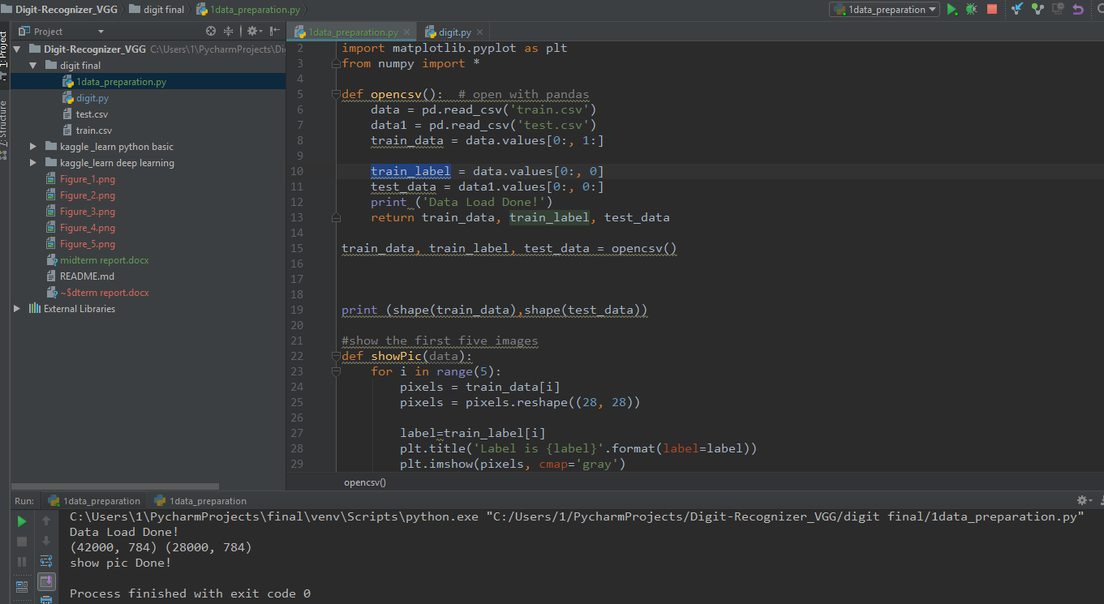

train data: (42000, 784)

42000 examples, each example has 784 pixels(28*28)

train label:(42000,1)

pre-labeled train data from 0-9,42000 examples

testing data :(28000, 784)

28000 examples, each example has 784 pixels(28*28)

pyplot to visualize the raw data

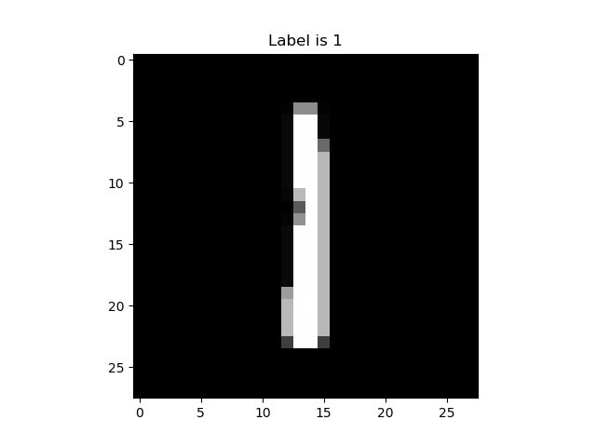

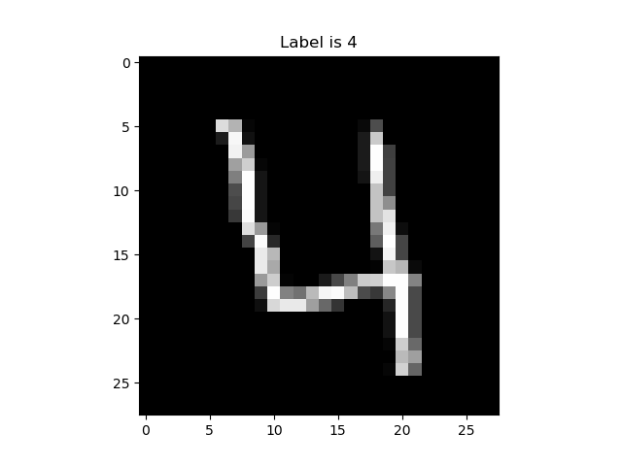

RESULTS

CONCLUSION

.